**IOT Watson Platform**

|  |  |
| --- | --- |
| Team ID | PNT2022TMID24775 |
| Project Name | IOT Based Industry-Specific Intelligent Fire  Management System |

Step1: log in your registered id

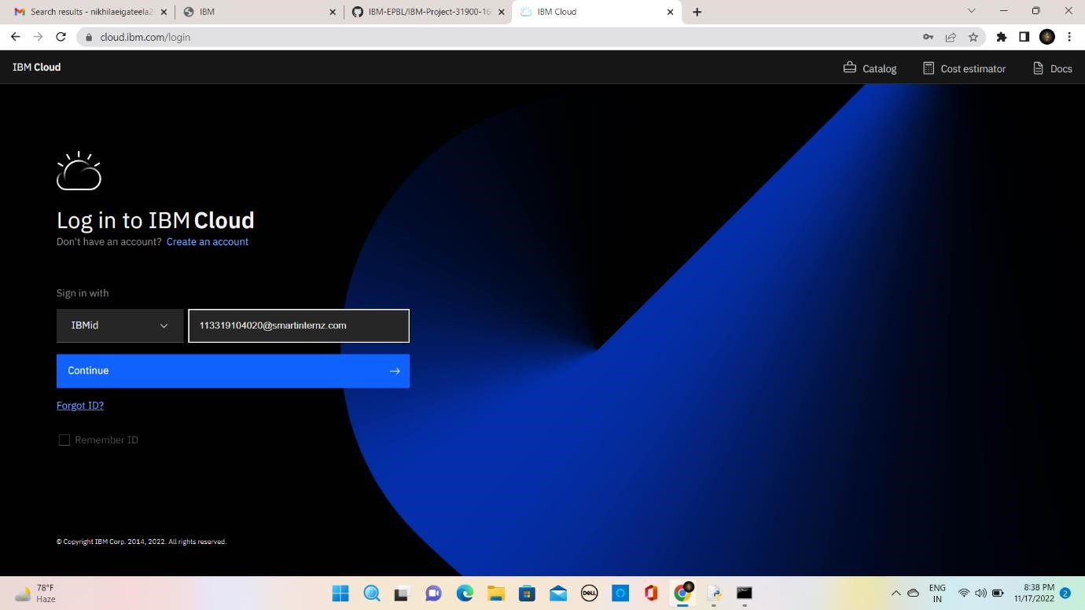

Step 2: click catalog where you find the services and internet of thing you can select and make location as London

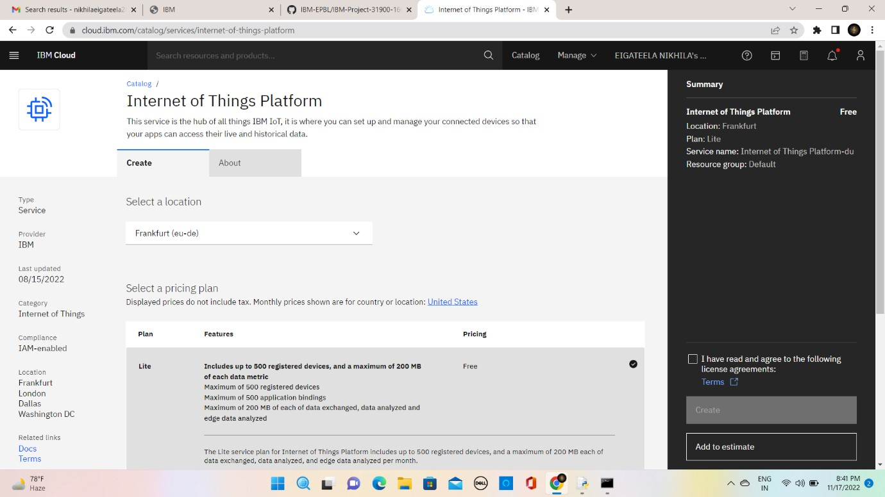

Step 3: click create and the launch tab get open, then click launch

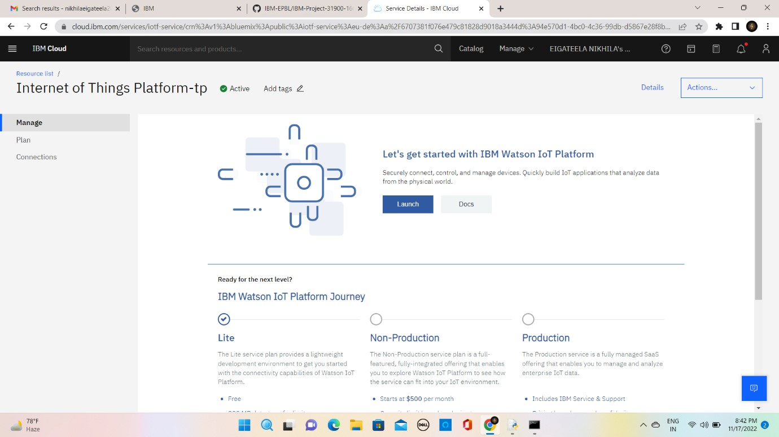

Step 4: It redirect you to IBM WATSON platform where you need to click sign in

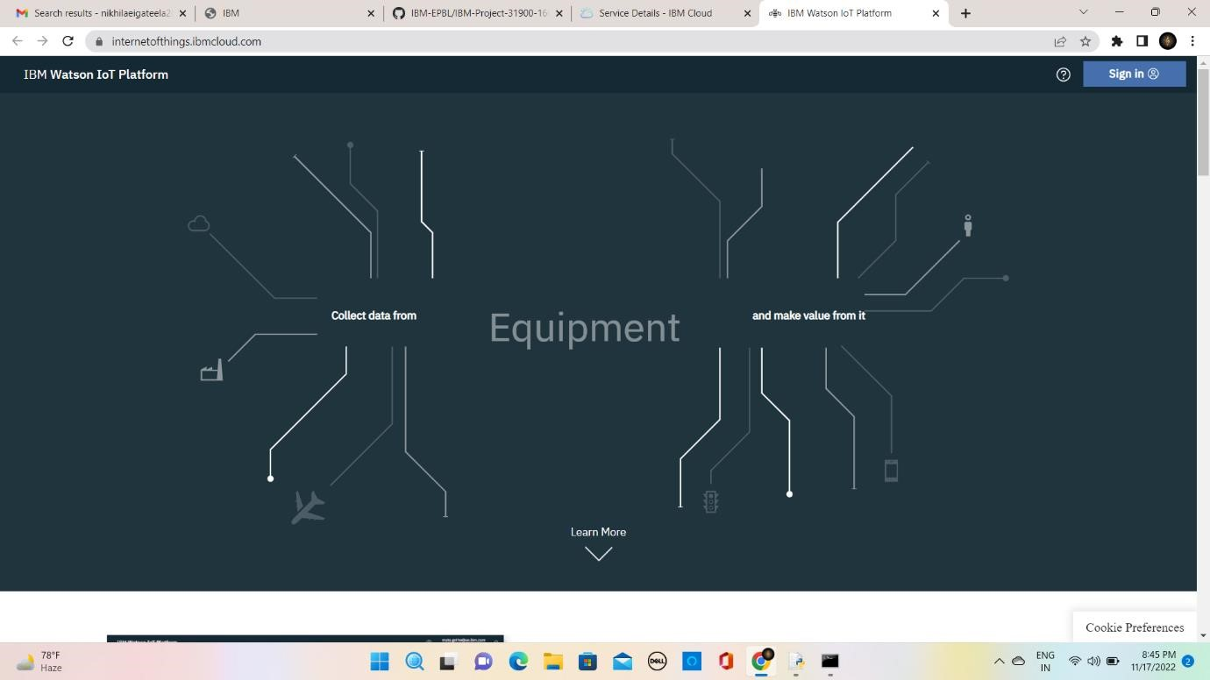

Step 5: you need to log in IBM ID

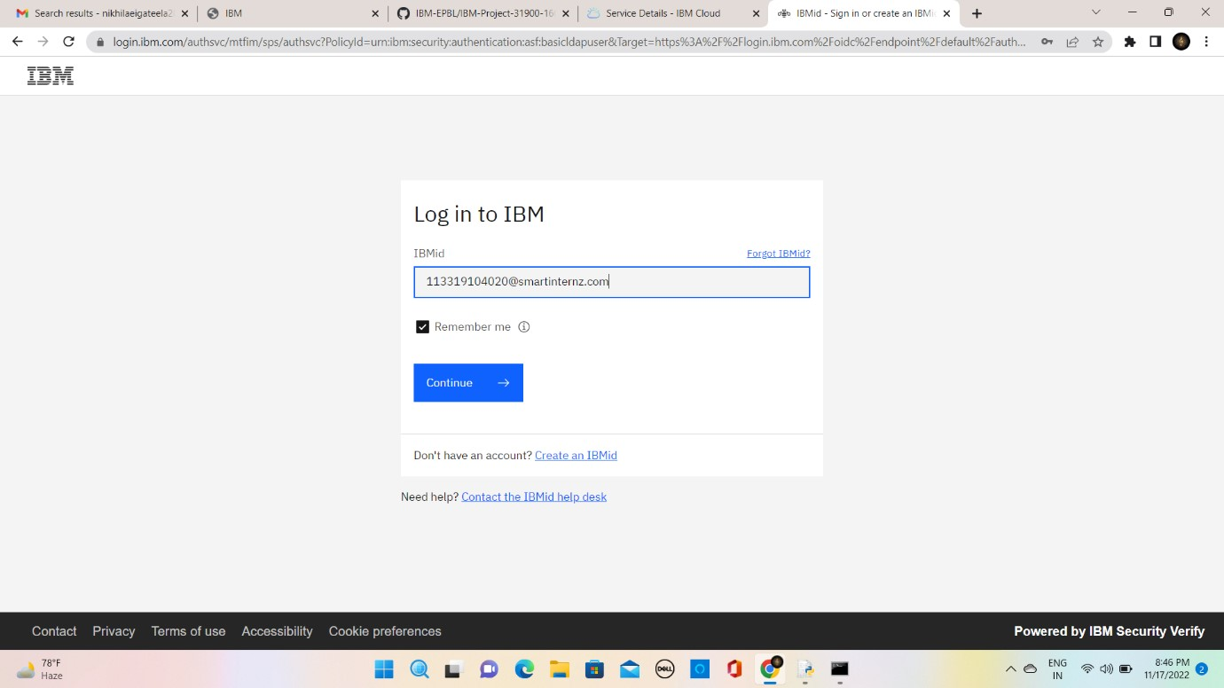

Step 6: where you find this tab which is used to add device , app, member ,usage , security can be worked

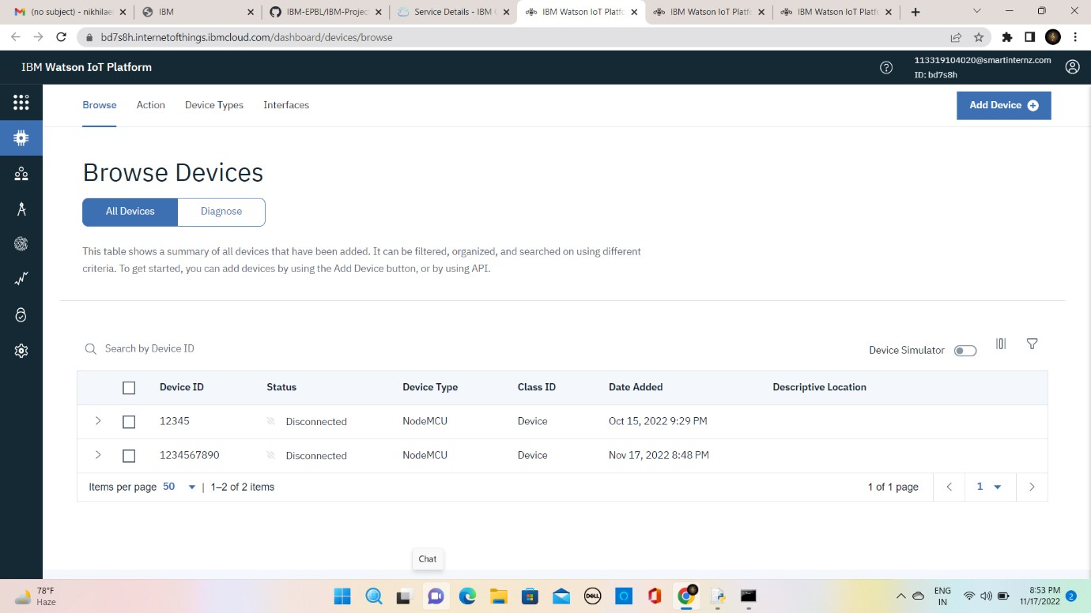

Step 7: check boards for risk and security overview card , it uses for graphical representation boards

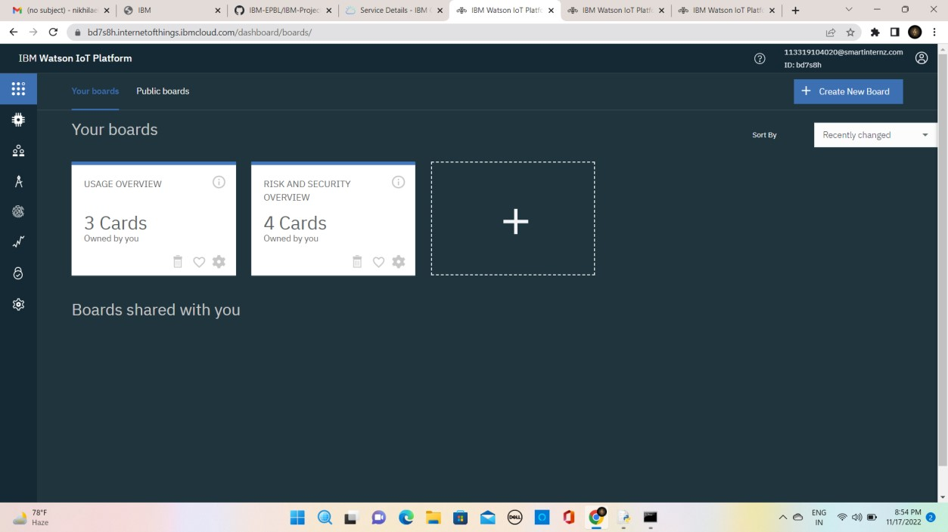

Step 8: after clicking create a new device / add device you can choose an device type and device id and complete the following information to create a device

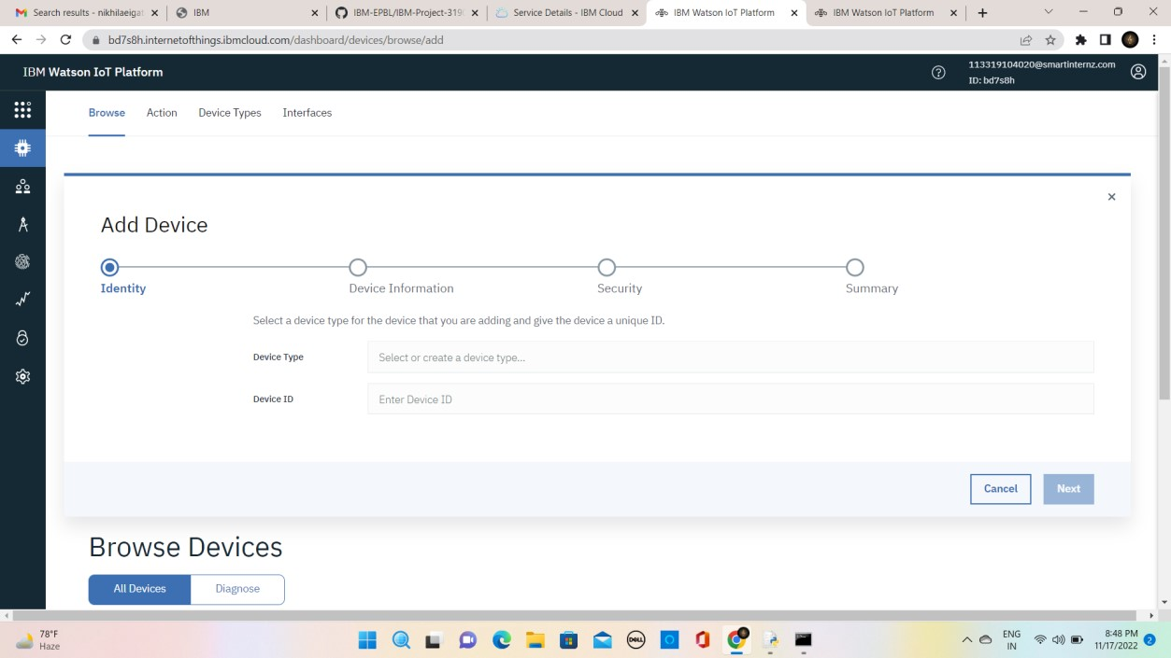

Step 9: created a device of ultrasonic_sensor

